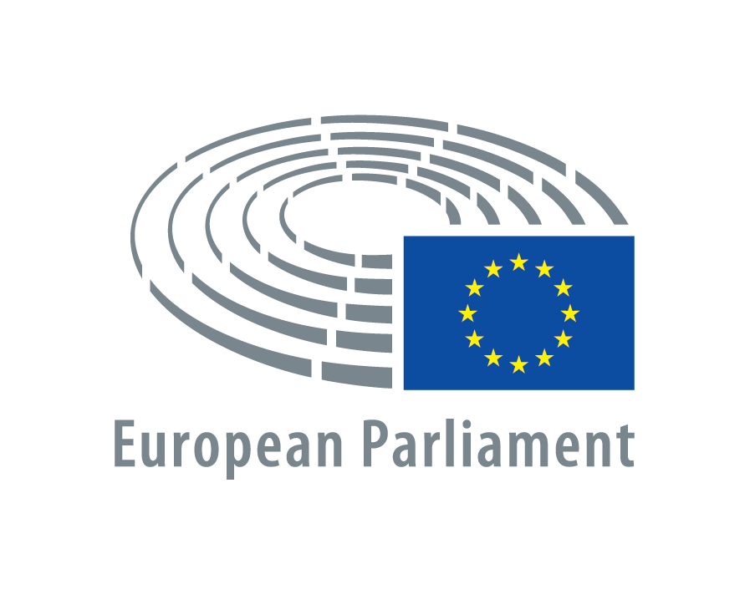

THE MARIA CURIE-SKŁODOWSKA UNIVERSITY – COLUMBIA
UNIVERSITY PRESS CONRAD PROJECT

CONRAD’S FOOTPRINTS
SIXTH INTERNATIONAL JOSEPH CONRAD CONFERENCE
MARIA CURIE-SKŁODOWSKA UNIVERSITY, LUBLIN, POLAND
20-24 June 2016

CIRCULAR II
CALL FOR ABSTRACTS

I. The Honorary Patronage and Dedication:
We are very happy and honored to announce that the conference will be held under the Honorary Patronage of The European Parliament and its President Mr. Martin Schulz.
The conference will be dedicated to East European Monographs, the co-publisher of volumes I-XXII of the series Conrad: Eastern and Western Perspectives, and Columbia University Press, the distributor of all the volumes of this series published so far (I-XXIV).

II. Abstracts:
We plan to publish a booklet of abstracts of papers prior to the conference and distribute it among participants on registration. The participants presenting papers are requested to submit their abstracts by November 20th, 2015 at the latest. The text, in English, should be no longer than 300 words (abstracts exceeding this word limit will be condensed by editors of the booklet). An abstract should contain no references. The heading of an abstract should contain its author’s name and surname, University, town and country, and the title of the paper. Please send your abstract as an e-mail attachment in Word.doc to the conference e-mail address (wieslaw.krajka@poczta.umcs.lublin.pl).

III. Scholarly program:
The scholarly proceedings will be composed of papers on various aspects of Joseph Conrad’s life and works, and related themes (Conrad’s Polish and East-Central European aspects and contexts will be one of the focuses of the conference). Apart from inaugural plenary lecture and concluding plenary lecture, all papers will be delivered in sections running in parallel sessions. Kinds of sessions and their number will be decided upon and announced when we fix the program of the conference. Each paper presentation should not exceed 35 minutes plus 10 minutes for discussion. English will be the official language of the conference.

IV. Publication of the conference papers:
Select papers from the conference will appear in two peer-reviewed volumes of the series Conrad: Eastern and Western Perspectives published by Maria Curie-Skłodowska University Press Lublin and distributed internationally by Columbia University Press New York (as a follow-up to the volumes of this series published so far). Presentation of a paper at the conference does not automatically guarantee its publication in the post-conference volumes. A paper submitted for publication consideration should be sent as an e-mail attachment to Prof. Wiesław Krajka’s e-mail address: wieslaw.krajka@poczta.umcs.lublin.pl
by 31st August 2016 at the latest (there is no length limit fixed for papers submitted for publication). Then, they will be subjected to regular peer-review process. Final versions of papers accepted for publication should be submitted to professor Wiesław Krajka’s e-mail address and in two hard copies to his postal address (English Department, Maria Curie-Skłodowska University, Pl. M. Curie-Skłodowskiej 4a, Lublin 20-031, Poland). The text, double-spaced, should be written in Word.doc and should follow the MLA Style Sheet.

V. Study tour:
From 24 to 30 June, following the conference, we plan a study tour of Conrad’s footprints in either Ukraine (taking in Lviv/Lvov, Berdychiv/Berdychev, Zhytomyr and Terechova) or Poland (taking in Lublin and environs, Cracow, Zakopane and Warsaw) – a final choice of one of these options will be made in January 2016 (depending on the political situation in Ukraine) and proposed to the conference participants in Circular III.

VI. Financial principles of the conference:
- Participants’ travel costs to Lublin and back are to be met by them.
- All individual costs of participation in the conference (especially accommodation and meals) are to be covered by participants themselves.
- There is no conference fee. All general costs of the conference are met by Maria Curie-Skłodowska University (the organizer and principal sponsor of the conference), and possibly by other sponsors. They include mainly the cost of hiring rooms for holding sessions, of printing the booklet of abstracts and the program of the conference, of transportation of participants during the conference.
- All costs of participation in the study tour of “Conrad’s footprints” are to be met by its participants. A tour fee will be fixed to cover the cost of transportation by coach on the tour.

VII. Financial contributions:
Conference participants are kindly invited and encouraged to contribute financially to the organizing committee to help it cover the general costs of the conference. Please wire the money, in either USD, EUR or PLN, to the following bank account:
SWIFT CODE: BREXPLPWLUB
IBAN: PL 96114010940000290516001014
Bank name: mBANK O/Korporacyjny Lublin
Address: ul. Krakowskie Przedmieście 6
City, postal code and country: Lublin, 20-002, Poland
Joseph Conrad Project
For transfers made in USD please add: 96 1140 1094 0000 2905 1600 1014
For transfers made in EUR please add: 83 1140 1094 0000 2905 1600 1054
For transfers made in PLN please add: 57 1140 1094 0000 2905 1600 1134

Please add „Joseph Conrad Project” to direct the money to us at the University.
Please do not send cheques. When sending your generous contribution please state clearly that you contribute to cover some general costs of the conference. Please do not wire any money to cover individual costs of your participation in our conference.

VIII. Communication and next circulars:
Information about the conference can be obtained from the following website:
www.conradcentre.umcs.eu
The conference address is:
Sixth International Joseph Conrad Conference; Prof. Dr Hab. Wiesław Krajka; Centre for Conrad Studies; English Department; Maria Curie-Skłodowska University; Pl. M. Curie-Skłodowskiej 4a; Lublin 20-031; Poland
Fax: (48) (81)537 5279
Phone: (48) (81)537 2634
E-mail: wieslaw.krajka@poczta.umcs.lublin.pl
Agata Łukasiewicz, M.A., is responsible for correspondence with the conference participants. Her e-mail address is: agatha.lukasiewicz@wp.pl
Circular III will be sent in January: it will provide mainly an outline of the program of the conference and the proposed Study Tour (24-30 June, 2016), registration forms, recommended accommodations for the conference and information about possible ways of reaching Lublin by plane, train and bus.
Circular IV (final) will be issued in June 2016: it will provide the program of the conference and indispensable final details concerning its organization.

Lublin, September 2015 Prof. Dr Hab. Wiesław Krajka
Chairman of the Organizing Committee

MARIA CURIE-SKŁODOWSKA UNIVERSITY

CALL FOR PAPERS

CONRAD’S FOOTPRINTS.
SIXTH INTERNATIONAL JOSEPH CONRAD CONFERENCE
AT MARIA CURIE-SKŁODOWSKA UNIVERSITY, LUBLIN, POLAND

Date of the conference: 20-24 June, 2016
Date of the study tour of Conrad’s footprints: 24-30 June, 2016

Place: Maria Curie-Skłodowska University, Lublin, Poland

Address: Prof. Dr. Hab. Wiesław Krajka
Centre for Conrad Studies, English Department
Maria Curie-Skłodowska University
Pl. Marii Curie-Skłodowskiej 4a
20-031 Lublin
Poland
e-mail: wiesław.krajka@poczta.umcs.lublin.pl
fax: (48)-(81)537-5279
phone: (48)-(81)537-2634
web: www.conradcentre.umcs.eu

LIST INFORMACYJNY nr 1
Zakład Studiów Conradoznawczych Instytutu Anglistyki Uniwersytetu Marii Curie-Skłodowskiej w Lublinie ma zaszczyt i przyjemność zorganizowania szóstej międzynarodowej konferencji conradowskiej w dniach 20-24 czerwca 2016r. Zapraszamy do udziału wszystkich badaczy i miłośników twórczości Conrada.
Na konferencji przedstawione zostaną referaty (w języku angielskim) dotyczące rozmaitych aspektów życia i twórczości Josepha Conrada i spraw z nimi związanych (konteksty polskie i środkowo-wschodnioeuropejskie Conrada należeć będą do głównych tematów konferencji). Wybrane referaty zostaną opublikowane w dwu recenzowanych tomach serii Conrad: Eastern and Western Perspectives publikowanej przez Wydawnictwo Uniwersytetu Marii Curie-Skłodowskiej w Lublinie w międzynarodowej dystrybucji Columbia University Press w Nowym Jorku.
Po konferencji, w dniach 24-30 czerwca 2016r., odbędzie się wyjazd studyjny śladami Conrada na Ukrainie (obejmujący Lwów, Berdyczów, Żytomierz i Terechową) lub w Polsce (obejmujący Lublin i Lubelszczyznę, Kraków, Zakopane i Warszawę) – ostateczny wybór przez organizatorów jednej z tych opcji nastąpi w styczniu 2016r. (zależnie od sytuacji politycznej na Ukrainie) i zostanie zaproponowany uczestnikom konferencji w Liście Informacyjnym nr 3.
Proszę przysłać deklarację uczestnictwa (z referatem lub bez referatu) na adres e-mailowy konferencji. Jeżeli znają Państwo osoby zainteresowane uczestnictwem w konferencji, proszę o zachęcenie ich do skontaktowania się.
List Informacyjny nr 2 zostanie wysłany we wrześniu 2015r. do osób, które zadeklarują uczestnictwo. Będzie zawierał informacje głównie o finansowych zasadach konferencji oraz zasadach dot. sporządzenia streszczenia zaproponowanego referatu.
Lublin, marzec 2015r. Prof. dr hab. Wiesław Krajka
Przewodniczący Komitetu Organizacyjnego

